**DAILY ONLINE ACTIVITIES SUMMARY**

|  |  |  |  |
| --- | --- | --- | --- |
| **Date:** | 15/06/2020 | **Name:** | Krishnitha |
| **Sem & Sec** | 4th sem, A Section | **USN:** | 4AL18CS039 |
| **Online Test Summary** | | | |
| **Subject** | NA | | |
| **Max. Marks** | NA | **Score** | NA |
| **Certification Course Summary** | | | |
| **Course** | Application Developer | | |
| **Certificate Provider** | AWS Educate | **Duration:** | 4 hrs |
| **Coding Challenges** | | | |
| **Problem Statement:**  Write a Java Program to find if string is K-Palindrome or not. | | | |
| **Status:** Executed | | | |
| **Uploaded the report in GitHub** | | YES | |
| **If yes Repository name** | | <https://github.com/krishnitha/Java-coding> | |
| **Uploaded the report in slack** | | YES | |

**Certification Course Details:**

Today I have continued the course “Application Developer” by AWS Educate. In this course today I learnt about ‘Programming and Scripting’. In programming I learnt about .Net, c, c++, c#, java and python programming language. And in Scripting I learnt about CLI, JavaScript, PHP, PowerShell and Ruby. I have also successfully completed the Assessment regarding this module.

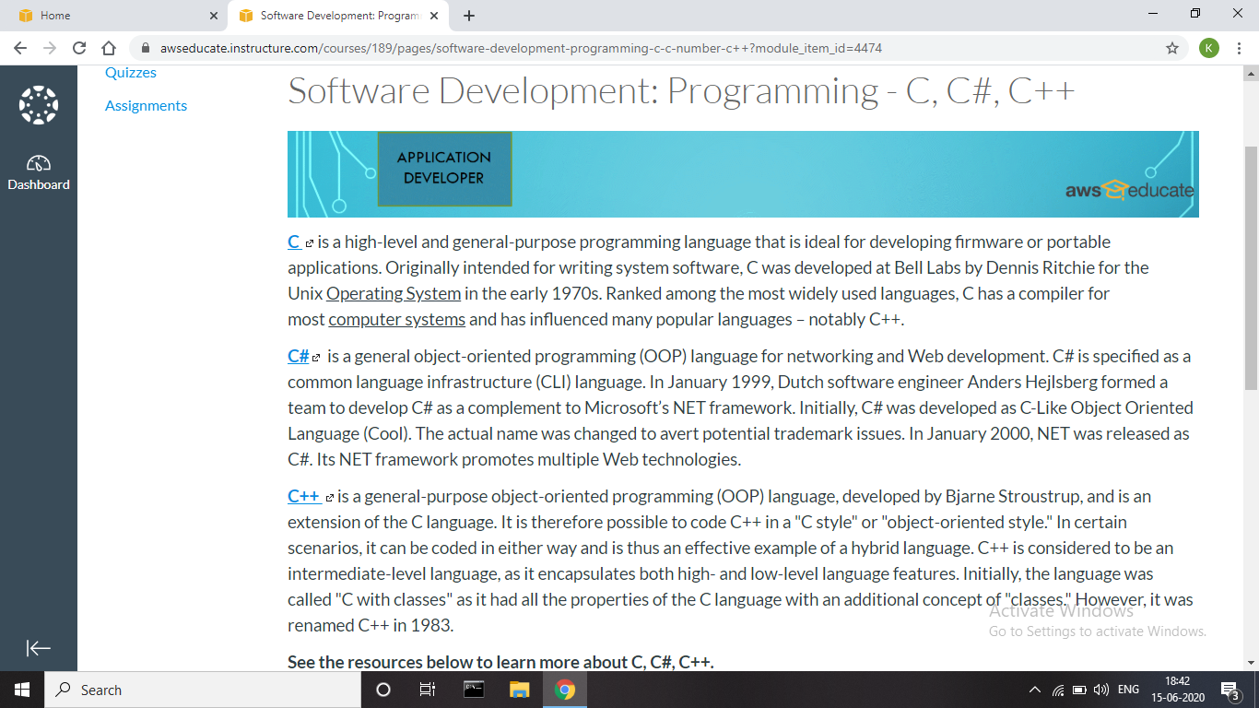



**Coding Challenges Details:**

**Problem:** Write a Java Program to find if string is K-Palindrome or not.

A string is k palindrome if it can be transformed into a palindrome on removing at most k characters from it. Your task is to complete the function is_k_palin which takes two arguments a string str and a number N . Your function should return true if the string is k palindrome else it should return false.

**Input:**The first line of input is an integer T denoting the number of test cases. Then T test cases follow. Each test case contains a string str and an integer N separated by space.

**Output:**The output will be 1 if the string is k palindrome else 0 .

**Example**  
Input: String - abcdecba, k = 1  
Output: Yes  
String can become palindrome by removing 1 character i.e. either d or e)

Input: String - abcdeca, K = 2  
Output : Yes  
Can become palindrome by removing  
2 characters b and e.

Input: String - acdcb, K = 1  
Output: No  
String can not become palindrome by  
removing only one character.

**Solution:** Uploaded it in GitHub

